Dennistoun Community Fun Day

@ Whitehill Secondary School,

Saturday 22nd August
12.00 – 4.00pm

Dennistoun Community Youth Project, Community Clubs,
Youth Services, Urban Fox, John Wheatley College,
Possibilities for East End Kids Project, The Gladiator Project, Eliminator! Assault Course, Bungee Run, Gladigator! Kids Bouncy Castles, Glasgow Works, Fair Trade, Stop Smoking Service, Climbing Wall, Face Painting, Henna Tattoo’s, Glasgow “Young Scot” Team, Café - Tea & Coffee +,
Strathclyde Fire Brigade, Sparkly PomPom! Chip Van Fire Unit,
Kids ‘n Co, East End Healthy Living Centre Roadshow, G.E.E.A.P,
Sadie’s Project, Community Safety Services Football & Basketball Pitch,
……….and lots, lots more!
Come along for a fun day out!!!!!!

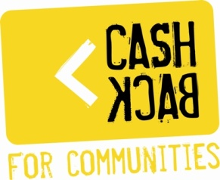
For more info contact Alan Murray @ 0141 554 1350; dcyp@hotmail.co.uk
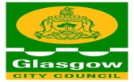
Dennistoun Community Charity Shop

